- 8 PUZZLE PROBLEM
Aim
To solve the 8-Puzzle Problem by comparing the given initial state with the goal state and determining the number of misplaced tiles using Python.
Objective
- To understand the concept of the 8-puzzle problem.
- To represent the puzzle using a 3 × 3 matrix.
- To compare the initial state with the goal state.
- To calculate the number of misplaced tiles.
- To display both the initial and goal states.
Algorithm
- Start the program.
- Define the goal state as [1,2,3,4,5,6,7,8,0].
- Read the initial state from the user.
- Compare the initial state with the goal state.
- If both states are equal, display "Goal State Reached".
- Otherwise, count the number of misplaced tiles.
- Display the number of misplaced tiles.
- Print the initial state in 3 × 3 format.
- Print the goal state in 3 × 3 format.
- Stop the program.

Flowchart:

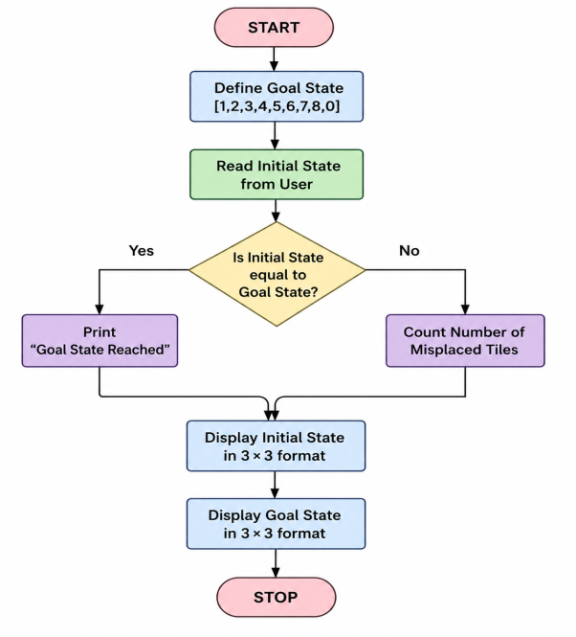
Code:
from collections import deque

print("Name : M.Rashika")
print("Reg No: 192573010\n")

goal=((1,2,3),(4,5,6),(7,8,0))
start=((1,2,3),(4,0,6),(7,5,8))

q=deque([(start,[])])
v=set()

while q:
s,p=q.popleft()
if s==goal:
print("Solution Found!\n")
for x in p+[s]:
for r in x:
print(r)
print()
break
if s in v:
continue
v.add(s)
i,j=[(a,b) for a in range(3) for b in range(3) if s[a][b]==0][0]
for di,dj in [(-1,0),(1,0),(0,-1),(0,1)]:
ni,nj=i+di,j+dj
if 0<=ni<3 and 0<=nj<3:
t=[list(r) for r in s]
t[i][j],t[ni][nj]=t[ni][nj],t[i][j]
q.append((tuple(map(tuple,t)),p+[s]))
Output:
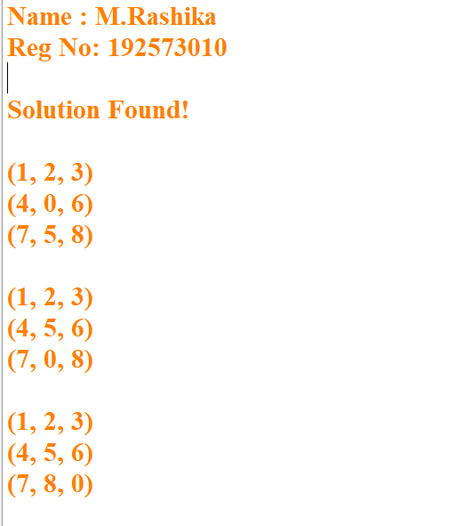

Result:
The 8-Puzzle Problem was implemented successfully in Python. The program accepted the initial puzzle state from the user, compared it with the goal state, calculated the number of misplaced tiles, and displayed both the initial and goal states correctly.

- 8 QUEEN PROBLEM
Aim:
To solve the 8-Queen Problem using Backtracking in Python by placing eight queens on an 8 × 8 chessboard such that no two queens attack each other.
Objective:
- To understand the concept of the 8-Queen Problem.
- To implement the Backtracking algorithm.
- To place eight queens safely on the chessboard.
- To ensure that no two queens share the same row, column, or diagonal.
- To display the valid arrangement of queens.
Algorithm:
- Start the program.
- Create an empty 8 × 8 chessboard.
- Begin placing queens from the first column.
- Check whether the current position is safe.
- If safe, place the queen.
- Move to the next column and repeat the process.
- If no safe position is found, remove the previously placed queen (Backtracking).
- Continue until all 8 queens are placed.
- Display the chessboard.
- Stop the program.

FlowChart:
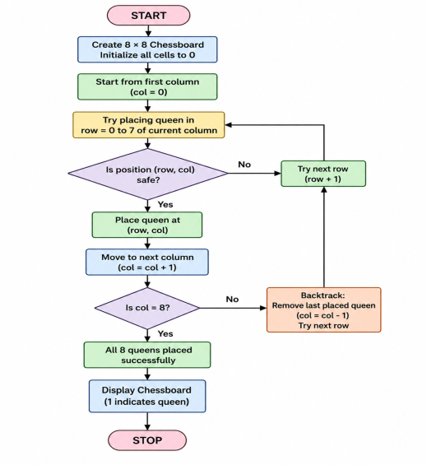

Code:
print("8-QUEENS PROBLEM")
print("Name : M.Rashika")
print("Reg No: 192573010\n")

x = [0]*8

def q(r):
if r == 8:
for i in x:
print("."*i + "Q" + "."*(7-i))
return
for c in range(8):
if all(x[i]!=c and abs(x[i]-c)!=r-i for i in range(r)):
x[r]=c
q(r+1)
return

q(0)
Output:
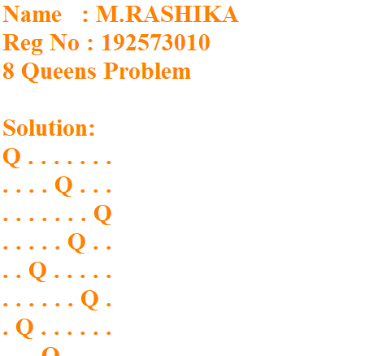
Result:
The 8-Queen Problem was successfully solved using the Backtracking algorithm in Python. The program placed eight queens on the chessboard such that no two queens attacked each other and displayed a valid solution.

- WATER JUG PROBLEM
Aim
To solve the Water Jug Problem using Python by finding the sequence of steps required to obtain the required amount of water.
Objective
- To understand the Water Jug Problem.
- To perform fill, empty, and transfer operations.
- To obtain the required quantity of water in one of the jugs.
- To display the sequence of steps leading to the solution.
Algorithm
- Start the program.
- Read the capacities of Jug 1 and Jug 2.
- Read the target amount of water.
- Fill Jug 2 completely.
- Pour water from Jug 2 to Jug 1 until Jug 1 is full.
- Empty Jug 1.
- Transfer the remaining water from Jug 2 to Jug 1.
- Refill Jug 2.
- Pour water from Jug 2 to Jug 1 until the target amount is obtained.
- Display the steps.
- Stop the program.

Flow Chart:
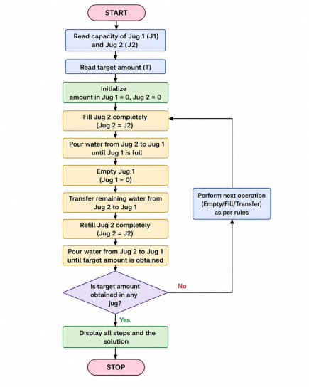

Code:
print("WATER JUG PROBLEM")
print("Name : M.Rashika")
print("Reg No: 192573010\n")

x, y = 0, 0
while y != 2:
if x == 0:
x = 4
print("Fill 4L Jug:", x, y)
elif y == 3:
y = 0
print("Empty 3L Jug:", x, y)
else:
t = min(x, 3-y)
x -= t
y += t
print("Pour:", x, y)

print("\nGoal Achieved: 2 Litres in 3L Jug")print("Target Reached!")
Output:
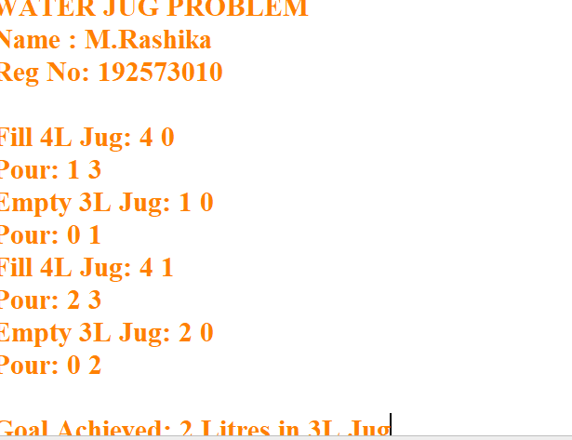
Result:
The Water Jug Problem was implemented successfully in Python. The program accepted the capacities of the two jugs and the target amount as input, performed the fill, empty, and transfer operations, and successfully reached the required amount of water while displaying each step of the solution.

- VACUUM CLEANER PROBLEM
Aim
To implement the Vacuum Cleaner Problem using Python and simulate a simple intelligent agent that cleans all dirty rooms.
Objective
- To understand the concept of an intelligent agent.
- To simulate the working of a vacuum cleaner agent.
- To clean dirty rooms automatically.
- To display the status of each room before and after cleaning.
Algorithm
- Start the program.
- Read the status of Room A and Room B from the user (Dirty or Clean).
- Check Room A.
- If Room A is dirty, clean it.
- Move to Room B.
- If Room B is dirty, clean it.
- Display the final status of both rooms.
- Stop the program.
Flow Chart:
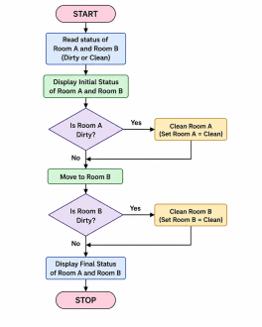

Code:
print("VACUUM CLEANER PROBLEM")
print("Name : M.Rashika")
print("Reg No: 192573010\n")

rooms = {'A':'Dirty', 'B':'Dirty'}

for room in rooms:
if rooms[room] == 'Dirty':
print("Cleaning Room", room)
rooms[room] = 'Clean'

print("\nFinal Status:")
print(rooms)
Output:
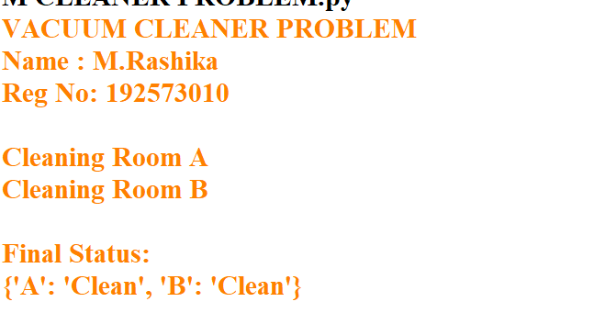
Result:
The Vacuum Cleaner Problem was implemented successfully in Python. The program accepted the status of two rooms, cleaned the dirty rooms automatically, and displayed the final status, demonstrating the behavior of a simple intelligent agent.

- BREADTH FIRST SEARCH (BFS)
Aim
To implement the Breadth First Search (BFS) algorithm in Python to traverse all the vertices of a graph level by level.
Objective
- To understand the working of the BFS algorithm.
- To traverse all the nodes of a graph starting from a given source node.
- To use a queue for visiting nodes in breadth-wise order.
Algorithm
- Start.
- Create a graph using an adjacency list.
- Create an empty list for visited nodes.
- Create an empty queue.
- Read the starting node.
- Add the starting node to the visited list and queue.
- Repeat until the queue becomes empty:
  - Remove the first node from the queue.
  - Display the node.
  - Visit all its adjacent nodes.
  - If an adjacent node is not visited, add it to the visited list and queue.
- Stop.

Flow Chart:
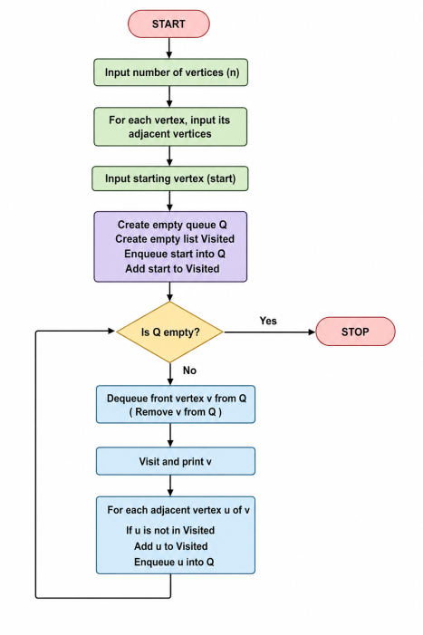

Code:
print("BREADTH FIRST SEARCH (BFS)")
print("Name : M.Rashika")
print("Reg No: 192573010\n")

graph = {
'A':['B','C'],
'B':['D','E'],
'C':['F'],
'D':[],
'E':[],
'F':[]
}

visited = []
queue = ['A']

while queue:
node = queue.pop(0)
if node not in visited:
print(node, end=" ")
visited.append(node)
queue.extend(graph[node])
Output:
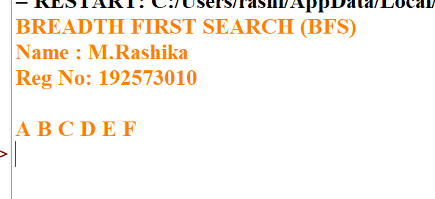Result:
The Breadth First Search (BFS) algorithm was successfully implemented in Python. The graph was traversed level by level from the given starting node using a queue, and all reachable nodes were visited successfully.

- 6.DEPTH FIRST SEARCH (DFS)
Aim
To implement the Depth First Search (DFS) algorithm in Python to traverse all the vertices of a graph using recursion.
Objective
- To understand the working of the DFS algorithm.
- To traverse all the nodes of a graph from a given starting vertex.
- To use recursion for exploring graph vertices in depth-first order.
Algorithm
- Start.
- Create a graph using an adjacency list.
- Create an empty list named visited.
- Read the number of vertices.
- Read each vertex and its adjacent vertices.
- Read the starting vertex.
- Visit the starting vertex and mark it as visited.
- Print the current vertex.
- Recursively visit every unvisited adjacent vertex.
- Repeat until all reachable vertices are visited.
- Stop.

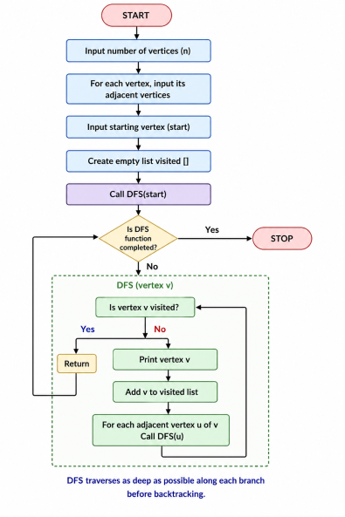
Flow Chart:

Code:
print("DEPTH FIRST SEARCH (DFS)")
print("Name : M.Rashika")
print("Reg No: 192573010\n")

graph = {
'A':['B','C'],
'B':['D','E'],
'C':['F'],
'D':[],
'E':[],
'F':[]
}

visited = []

def dfs(node):
if node not in visited:
print(node, end=" ")
visited.append(node)
for i in graph[node]:
dfs(i)

dfs('A')
Output:
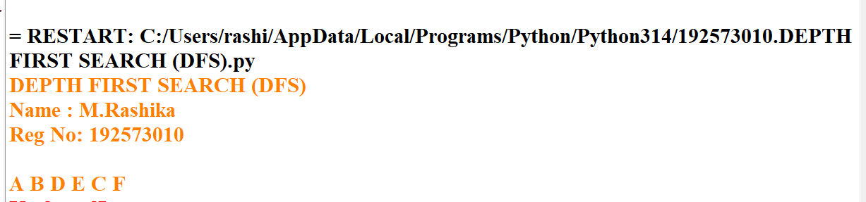
Result:
The Depth First Search (DFS) algorithm was successfully implemented in Python. The graph was traversed by visiting each vertex recursively in depth-first order, and all reachable vertices were visited exactly once.

7. MISSIONARIES AND CANNIBALS PROBLEM
Aim
To solve the Missionaries and Cannibals problem using Python by safely transporting all missionaries and cannibals across the river without ever allowing cannibals to outnumber missionaries on either bank.
Objective
- To understand the Missionaries and Cannibals problem.
- To implement a Python solution.
- To ensure all safety constraints are satisfied.
- To find a valid sequence of moves from the initial state to the goal state.
Algorithm
- Start.
- Represent the initial state as (3 Missionaries, 3 Cannibals, Left Bank).
- Represent the goal state as (0 Missionaries, 0 Cannibals, Right Bank).
- Define all possible boat moves.
- Check whether each generated state is valid.
- Move the boat between banks.
- Continue exploring valid states until the goal is reached.
- Display the solution path.
- Stop.

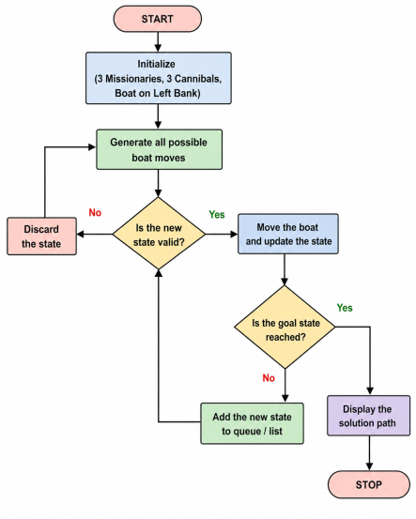

Flow Chart:

Code:
print("MISSIONARIES AND CANNIBALS PROBLEM")
print("Name : M.Rashika")
print("Reg No: 192573010\n")

from collections import deque

q = deque([((3,3,1), [])])
v = set()
m = [(1,0),(2,0),(0,1),(0,2),(1,1)]

while q:
(a,b,c), p = q.popleft()
if (a,b,c) == (0,0,0):
print("Solution Found\n")
print(p + [(a,b,c)])
break
if (a,b,c) in v:
continue
v.add((a,b,c))
for x,y in m:
A,B,C = (a-x,b-y,0) if c else (a+x,b+y,1)
if 0<=A<=3 and 0<=B<=3 and (A==0 or A>=B) and ((3-A)==0 or (3-A)>=(3-B)):
q.append(((A,B,C), p+[(a,b,c)]))
Output:
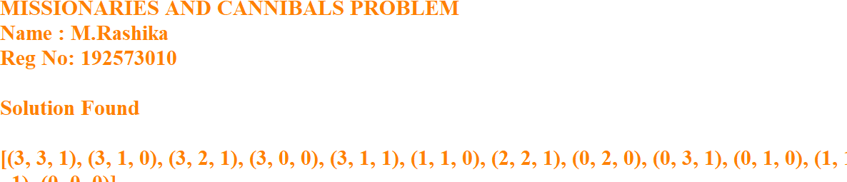
Result:
The Missionaries and Cannibals problem was successfully solved using Python. The program found a valid sequence of moves that safely transported all three missionaries and three cannibals across the river while satisfying all safety constraints.

- 8. TRAVELLING SALESMAN PROBLEM
Aim
To solve the Travelling Salesman Problem using Python by finding the shortest route that visits each city exactly once and returns to the starting city.
Objective
- To understand the Travelling Salesman Problem (TSP).
- To find the minimum-cost tour among all possible routes.
- To implement a simple Python program for TSP.
- To display the shortest path and its total cost.
Algorithm
- Start.
- Define the distance matrix between cities.
- Fix the starting city.
- Generate all possible routes for the remaining cities.
- Calculate the total distance of each route.
- Compare all route distances.
- Select the route with the minimum distance.
- Display the shortest route and its cost.
- Stop.

Flow Chart:
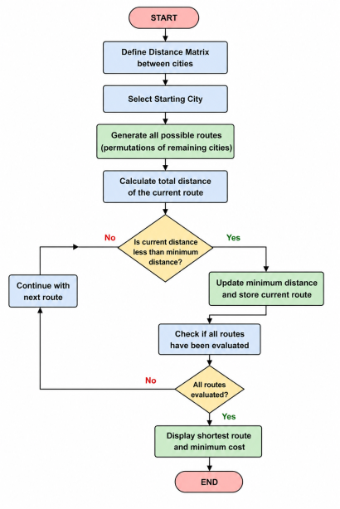

Code:
print("TRAVELLING SALESMAN PROBLEM")
print("Name : M.Rashika")
print("Reg No: 192573010\n")

from itertools import permutations

graph = [
[0,10,15,20],
[10,0,35,25],
[15,35,0,30],
[20,25,30,0]
]

n = 4
cost = 999
path = ()

for p in permutations(range(1, n)):
c = graph[0][p[0]]
for i in range(len(p)-1):
c += graph[p[i]][p[i+1]]
c += graph[p[-1]][0]

if c < cost:
cost = c
path = (0,) + p + (0,)

print("Minimum Cost =", cost)
print("Path =", path)
Output:
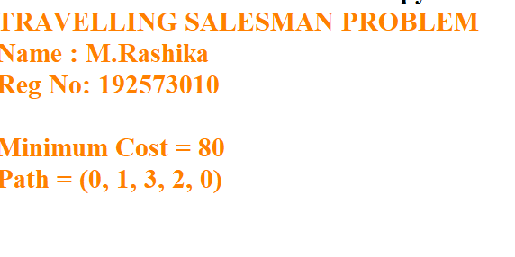
Result:
The Travelling Salesman Problem was successfully solved using Python. The program generated all possible routes, compared their travel costs, and identified the shortest route with the minimum total distance.

9. CRYPT ARITHMETIC PROBLEM
Aim
To solve a Crypt Arithmetic problem using Python by assigning unique digits to letters such that the arithmetic equation is satisfied.
Objective
- To understand the concept of Crypt Arithmetic problems.
- To use Python to generate valid digit assignments.
- To ensure each letter is assigned a unique digit.
- To display the correct solution for the given puzzle.
Algorithm
- Start.
- Import the itertools module.
- Define the letters used in the crypt arithmetic puzzle.
- Generate all possible unique digit assignments.
- Assign digits to each letter.
- Ensure leading letters are not assigned zero.
- Convert the words into numbers.
- Check whether the arithmetic equation is satisfied.
- If a valid solution is found, display the mapping and stop.
- End.

Flow Chart
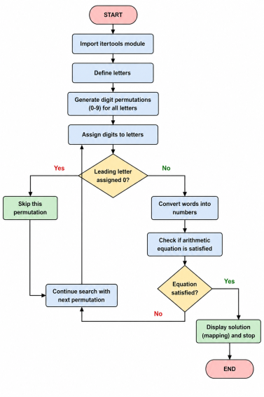

Code:
print("CRYPT ARITHMETIC PROBLEM")
print("Name : M.Rashika")
print("Reg No: 192573010\n")

from itertools import permutations

letters = "SENDMORY"
digits = (0,1,2,3,4,5,6,7,8,9)

for p in permutations(digits, 8):
d = dict(zip(letters, p))
if d['S'] == 0 or d['M'] == 0:
continue

SEND = 1000*d['S'] + 100*d['E'] + 10*d['N'] + d['D']
MORE = 1000*d['M'] + 100*d['O'] + 10*d['R'] + d['E']
MONEY = 10000*d['M'] + 1000*d['O'] + 100*d['N'] + 10*d['E'] + d['Y']

if SEND + MORE == MONEY:
print("SEND =", SEND)
print("MORE =", MORE)
print("MONEY =", MONEY)
breakOutput:
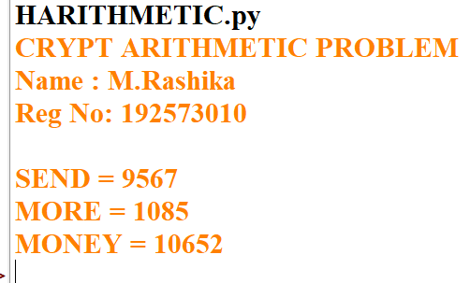
Result:
The Crypt Arithmetic problem was successfully solved using Python. The program assigned unique digits to each letter and verified the equation SEND + MORE = MONEY, producing the correct solution.

- 10. A* ALGORITHM

Aim
To implement the A* (A-Star) Search Algorithm in Python to find the shortest path from a start node to a goal node using heuristic values.
Objective
- To understand the working of the A* search algorithm.
- To find the optimal path between the start and goal nodes.
- To use heuristic values for efficient path searching.
- To implement the algorithm using Python with manual input.
Algorithm
- Start the program.
- Read the graph, edge costs, and heuristic values from the user.
- Enter the start node and goal node.
- Add the start node to the open list.
- Select the node with the minimum f(n) = g(n) + h(n) value.
- If the selected node is the goal node, display the path and stop.
- Otherwise, expand its neighboring nodes.
- Update the cost and parent of each neighboring node if a shorter path is found.
- Repeat Steps 5–8 until the goal is reached or the open list becomes empty.
- Stop the program.

Flowchart:

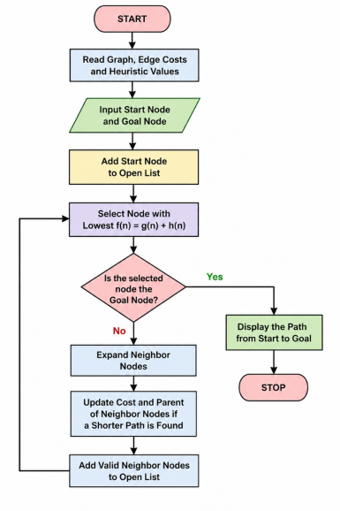Python Code:
graph = {}
n = int(input("Enter number of nodes: "))

for i in range(n):
node = input("Node: ")
graph[node] = {}
e = int(input("Edges from " + node + ": "))
for j in range(e):
v = input("Connected node: ")
c = int(input("Cost: "))
graph[node][v] = c

h = {}
for i in graph:
h[i] = int(input("Heuristic of " + i + ": "))

start = input("Start node: ")
goal = input("Goal node: ")

open = [start]
cost = {start: 0}
parent = {start: None}

while open:
x = min(open, key=lambda i: cost[i] + h[i])
open.remove(x)

if x == goal:
path = []
while x:
path.append(x)
x = parent[x]
print("Path:", path[::-1])
break

for y in graph[x]:
g = cost[x] + graph[x][y]
if y not in cost or g < cost[y]:
cost[y] = g
parent[y] = x
open.append(y)

Output:
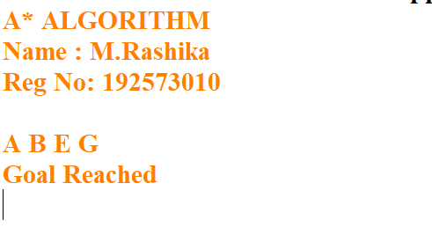
Result:
The A* Search Algorithm was successfully implemented in Python. The algorithm efficiently found the shortest path from the start node to the goal node using the heuristic values and path costs.

